Special Access Medical Device
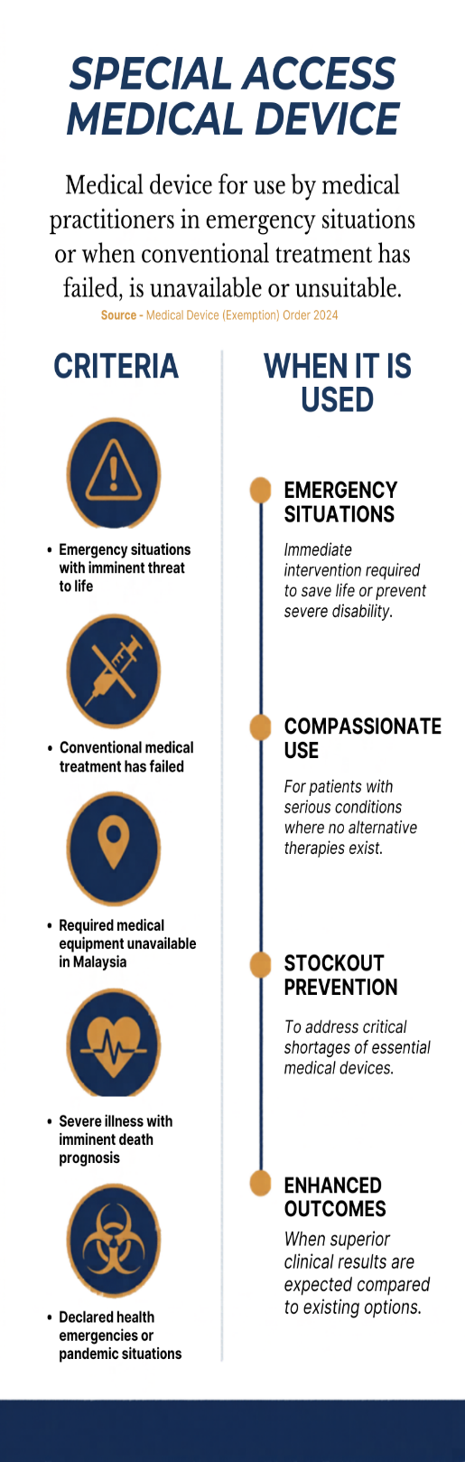
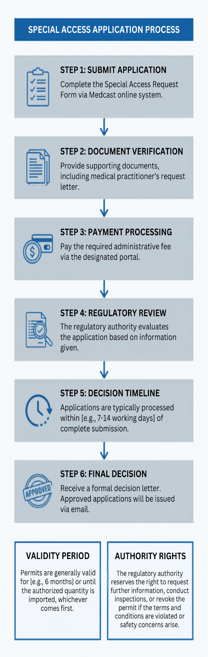

Legal/Guidance Documents:
- Medical Device (Exemption) Order 2024
- MDA/GD/0043 – Special Access Exemption Application

How to Submit Application :
- Application form : Medcast
- How to create Medcast Account : Medcast – Notification Creation
- Administrative Fee : RM 300

Reference Documents:
- Essential Requirement: Medcast form
- Medical Practitioner’s Request Letter : Template
- Post handling : Disposal Form

Contact Information:
- General Email: [ sa.cm@mda.gov.my ]
- Admin : Mohamad Aznil | ☎ +603-82300 0247

Officers in Charge :
- Pn. Nur Maizura Bt Zarmani | ☎ +603-8230 0339
- Pn. Aidahwaty Bt Ariffin | ☎ +603-8230 0364

Importance Notice :

Please be advised that applications that do not meet stated criteria or lack proper justification will be rejected.

To qualify for Special Access Notification, all applicants must possess a valid establishment license, specifically as an Authorized Representative and Importer.

